- Change label Number to INC Number
- Caller location should come in Incident form
  - User form should have location field
  - Incident form should also have location field
- Add New Category in the incident form
- Add VIP infront of Caller name

- Change label Number to INC Number

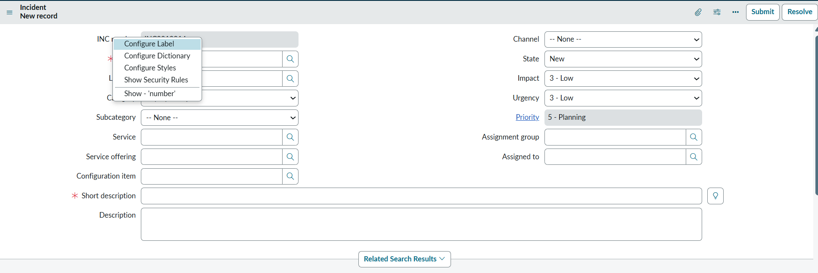
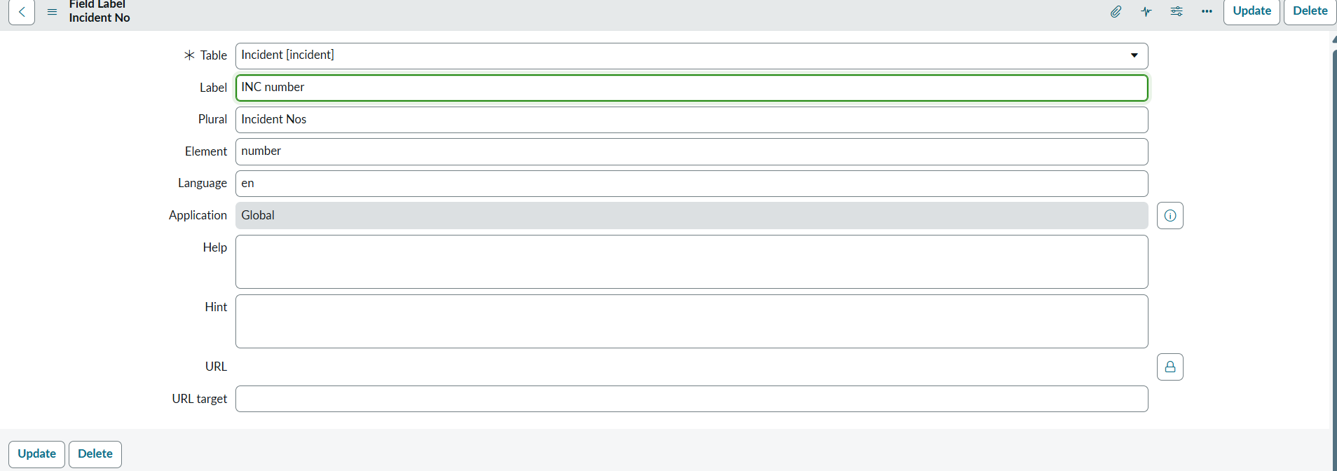
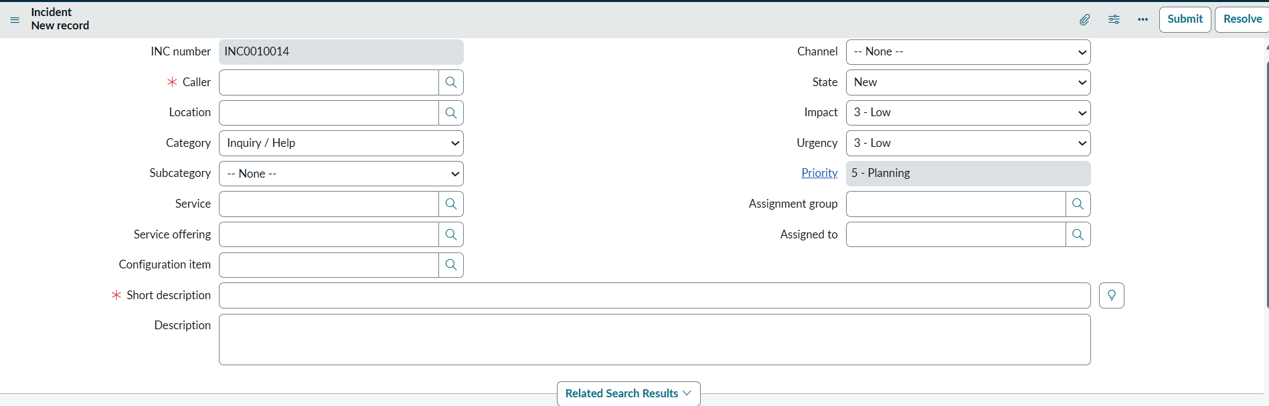

Done Step 1

- Caller location should come in Incident form –
  - User form should have location field
  - Incident form should also have location field

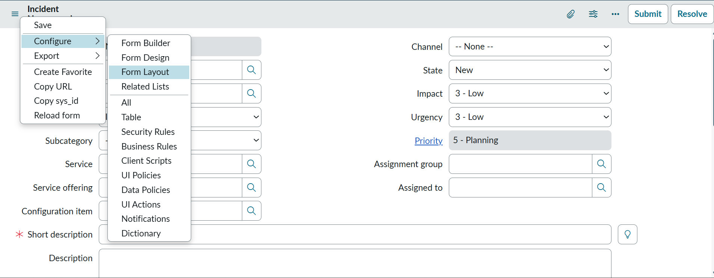

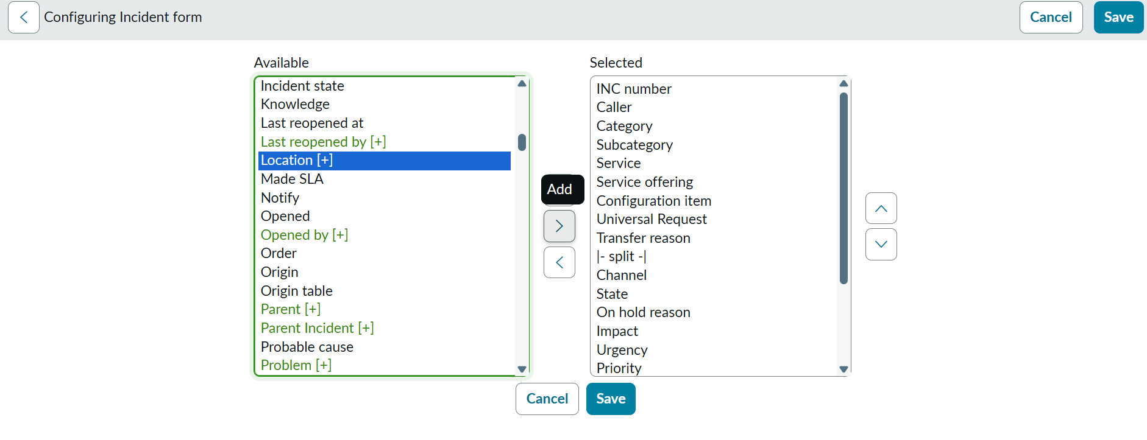
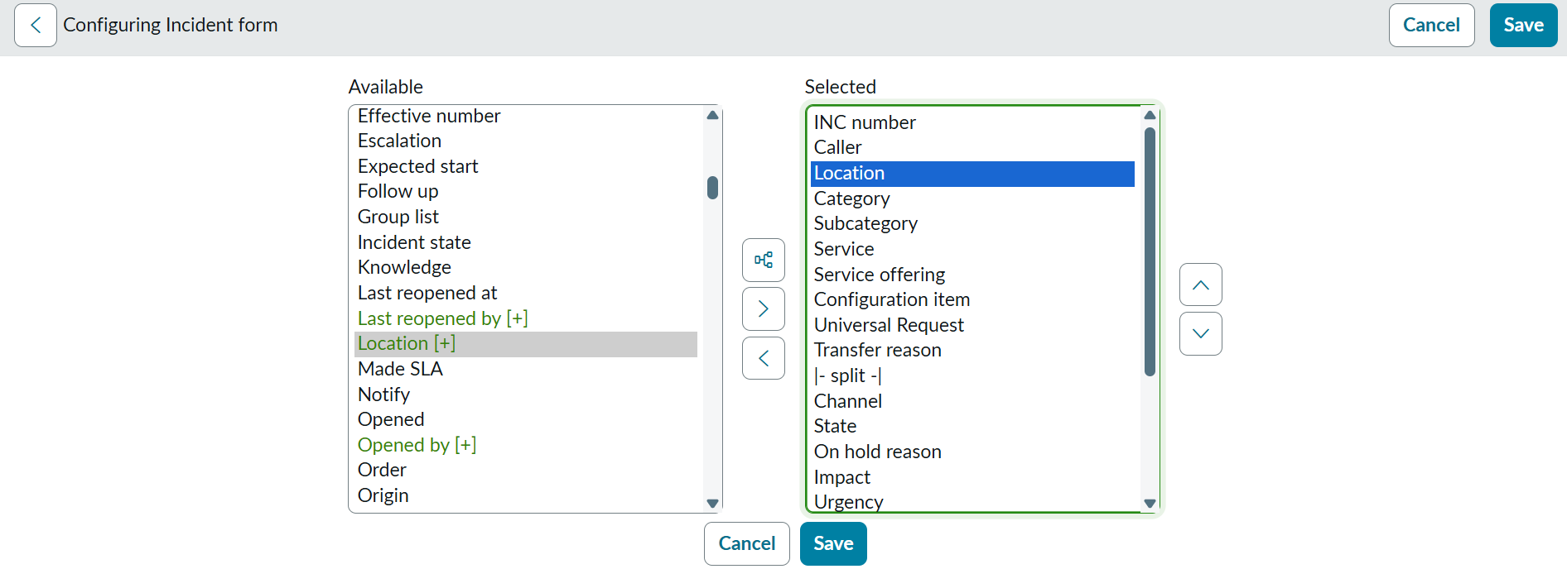
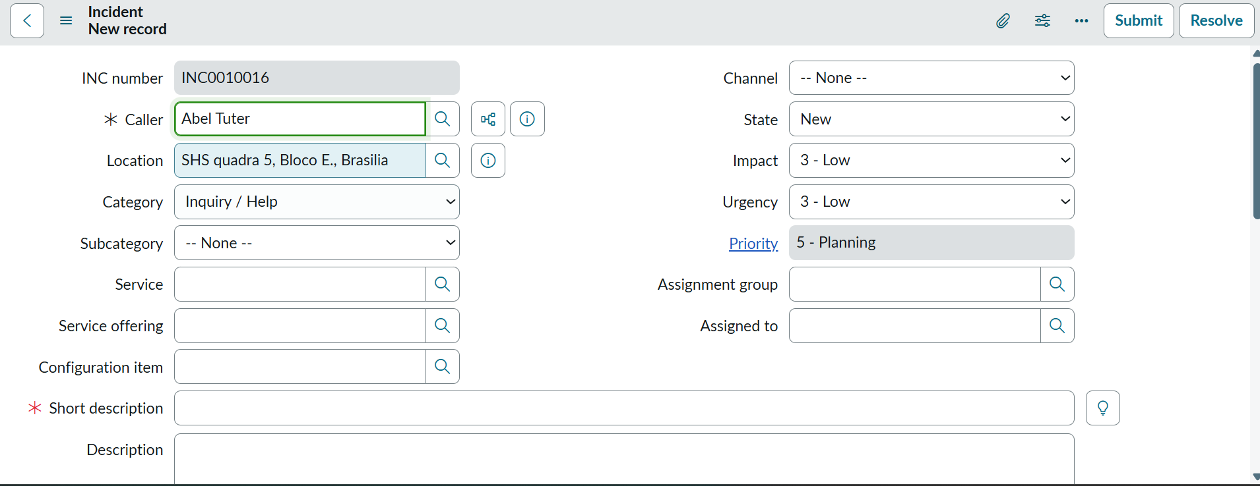
Done Step 2

- Add New Category in incident form
Add Wireline in subcategory of Network
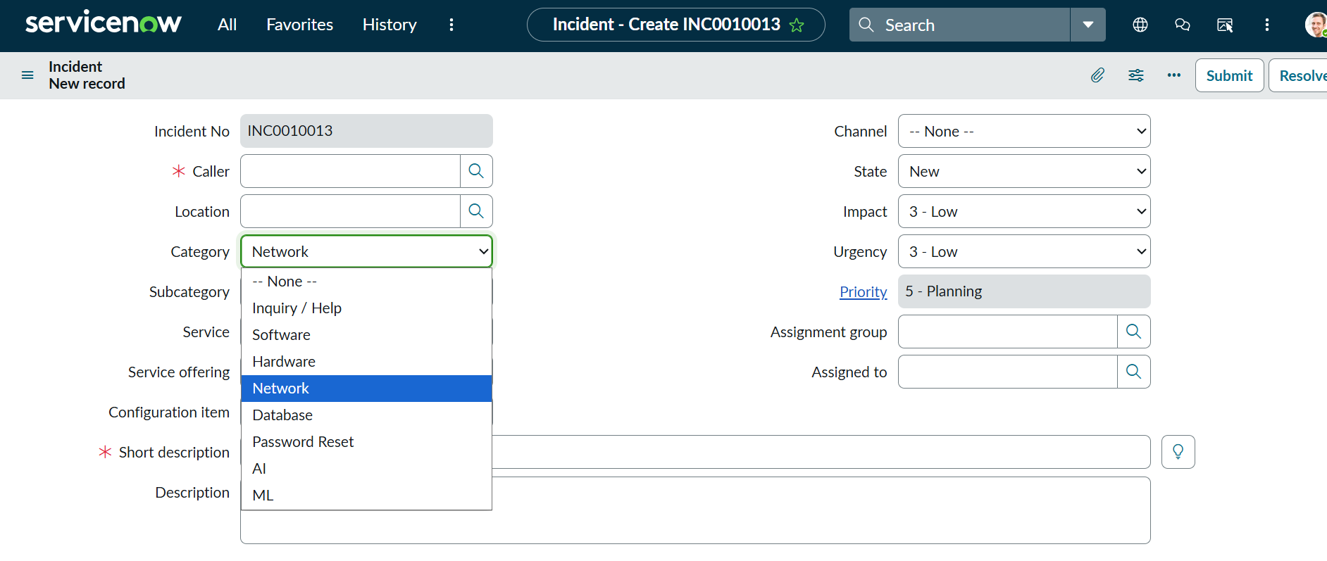
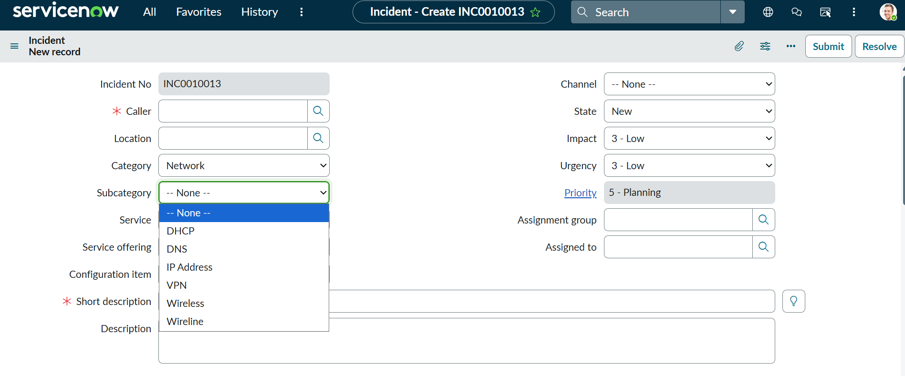
Add AI as new category and add AI related subcategories…

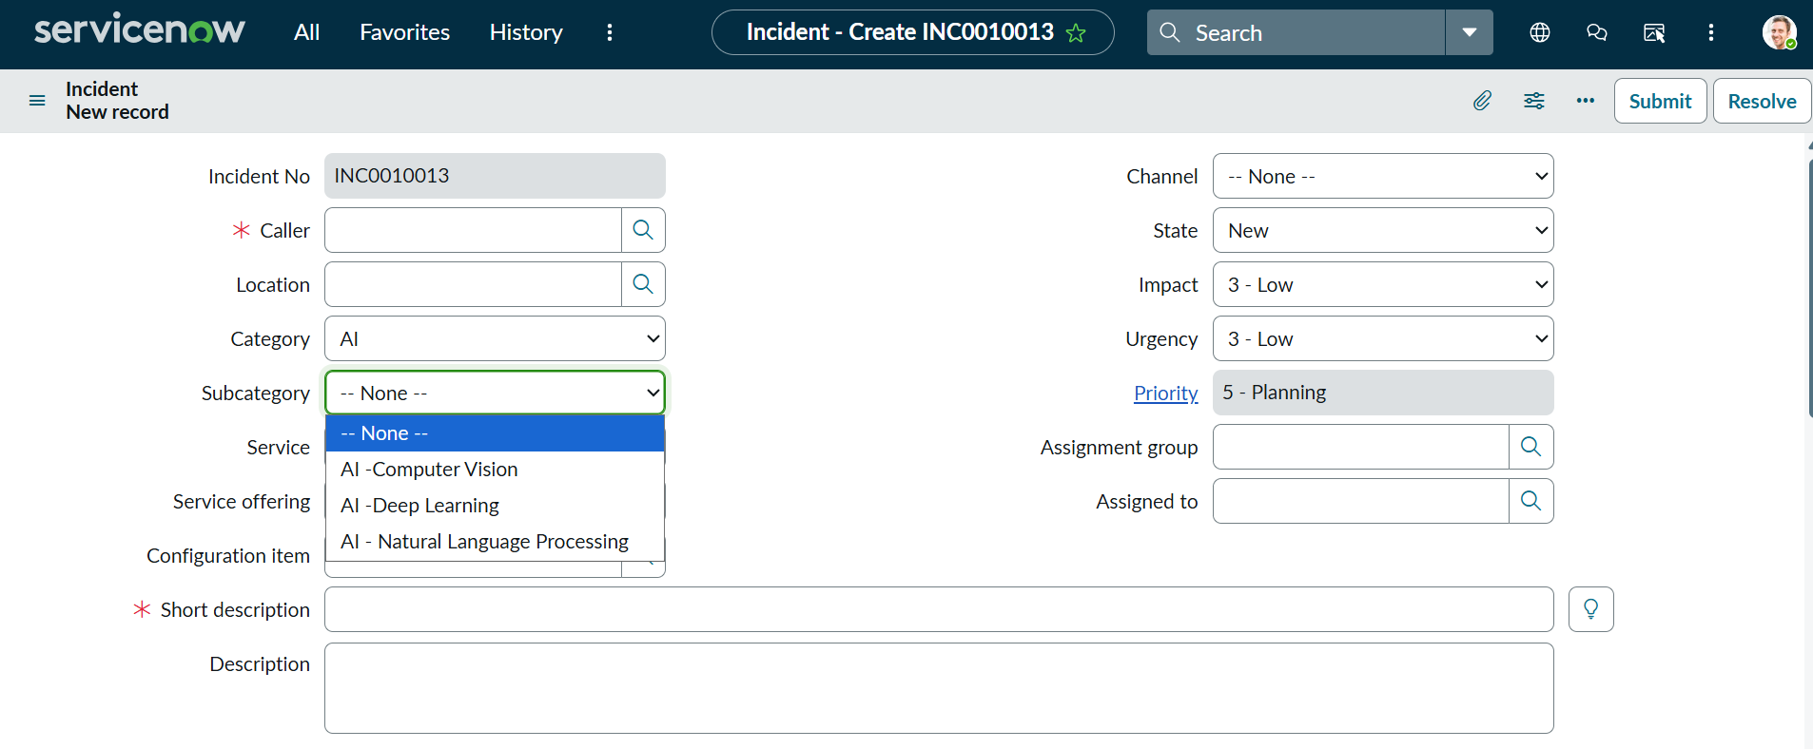
Done Step 3

- Add VIP infront of Caller name
Go to user form….
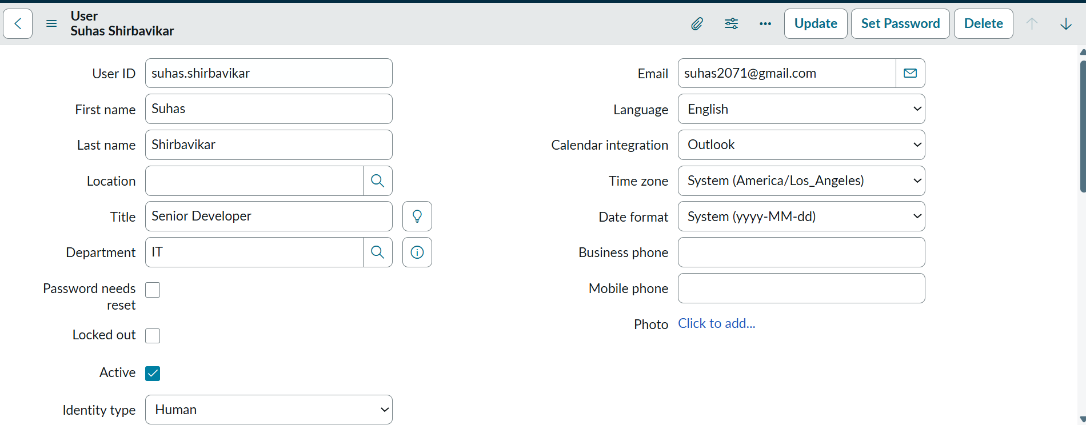
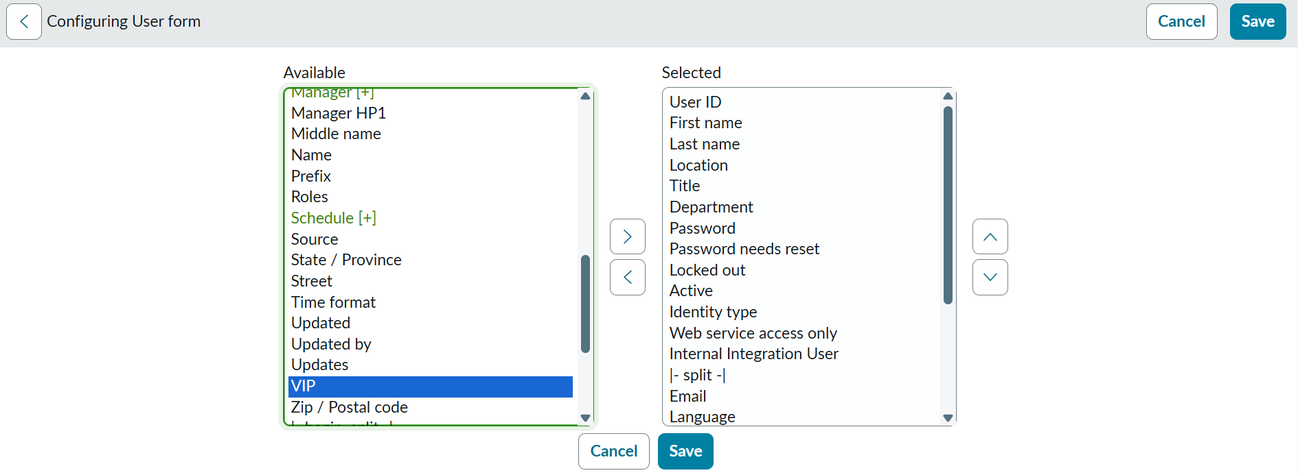
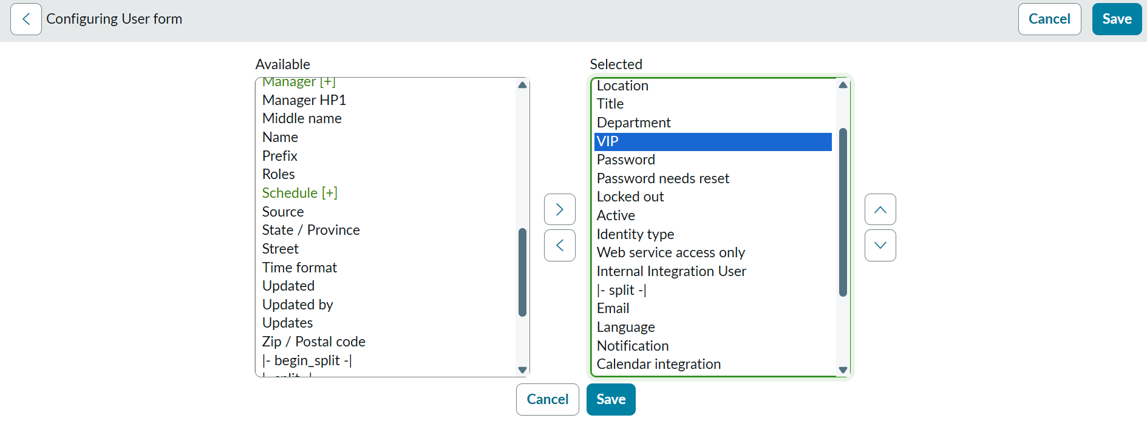
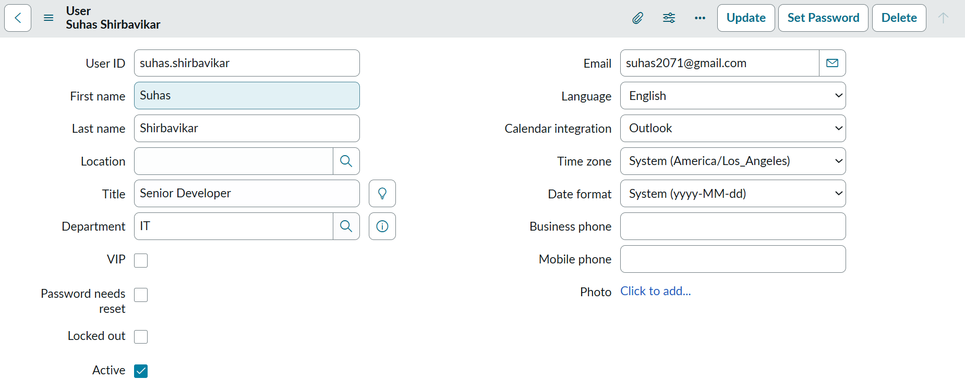
User form is having VIP field…
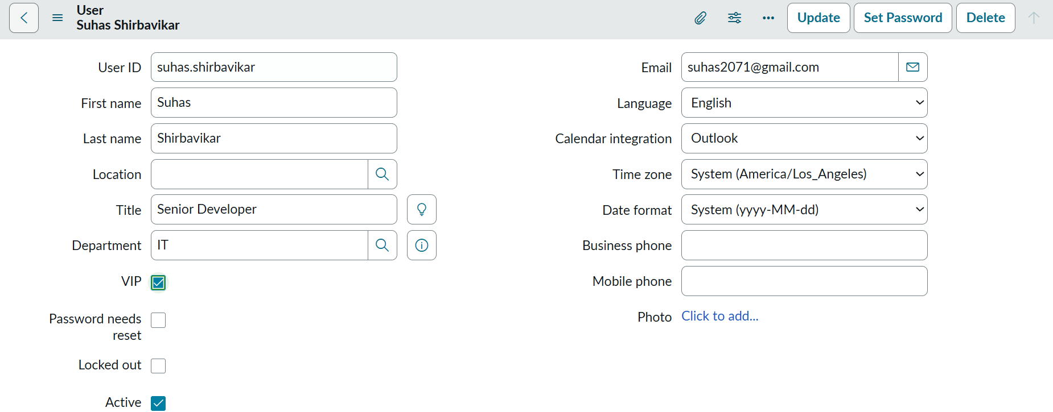

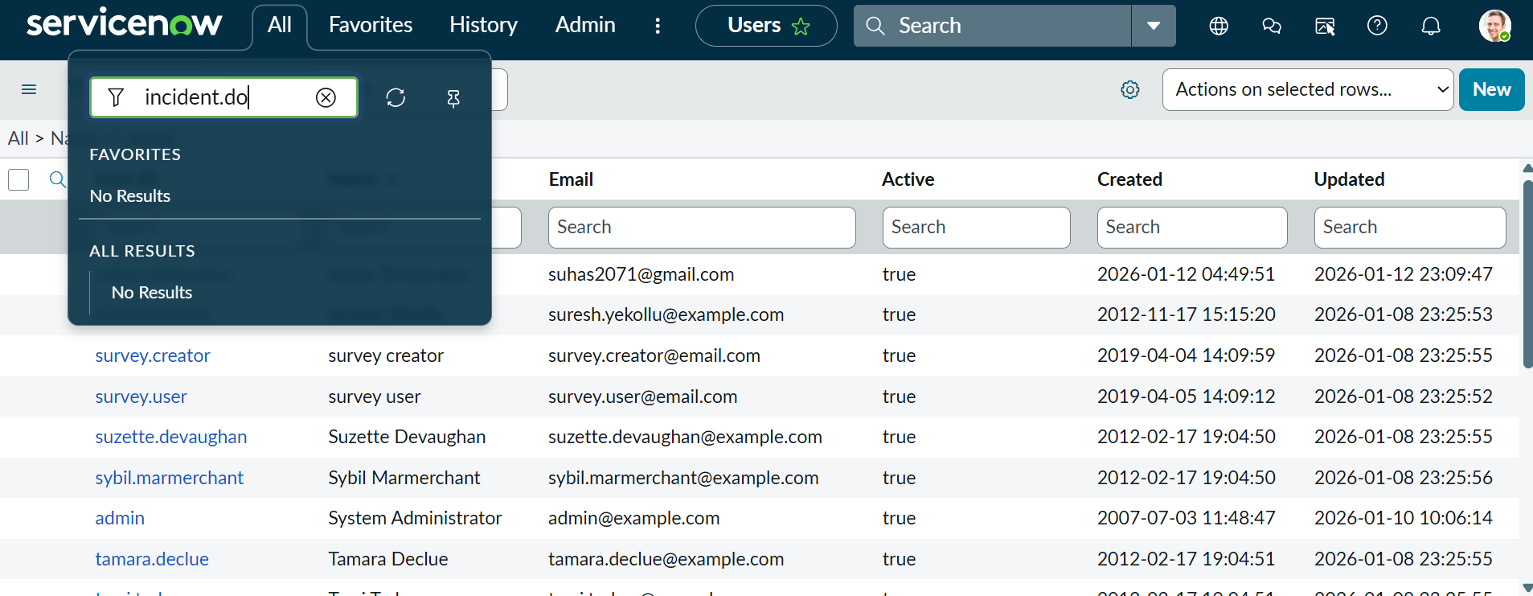
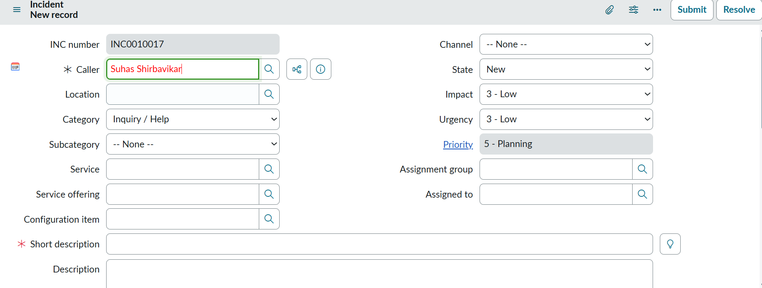
Done Step 4

Other ways to do………

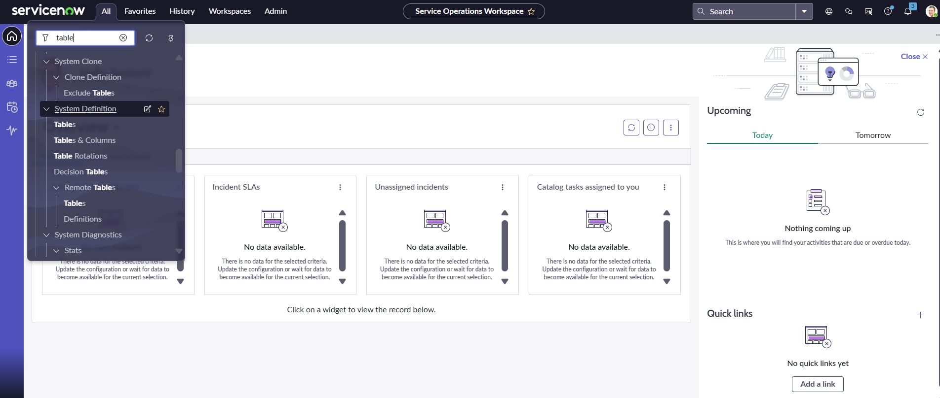
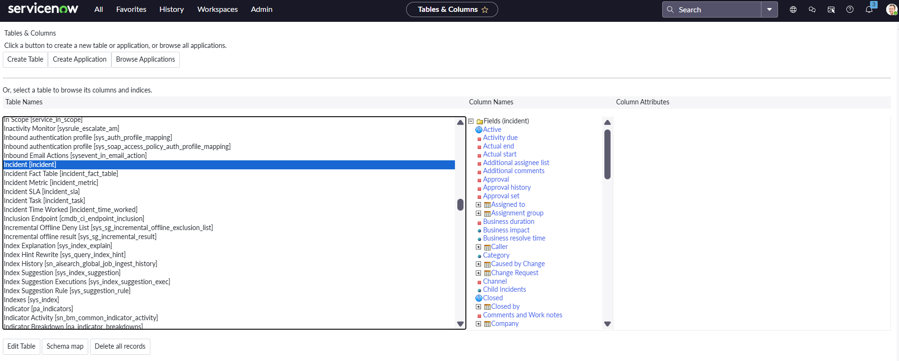
Click on Edit Table …..
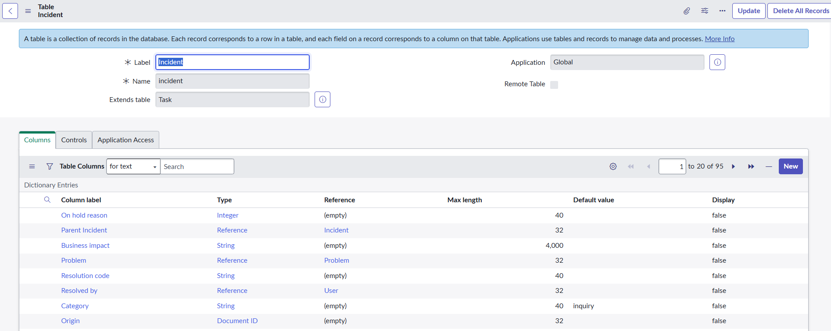
Double click on Category …
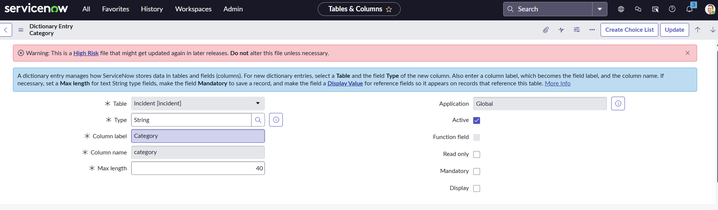
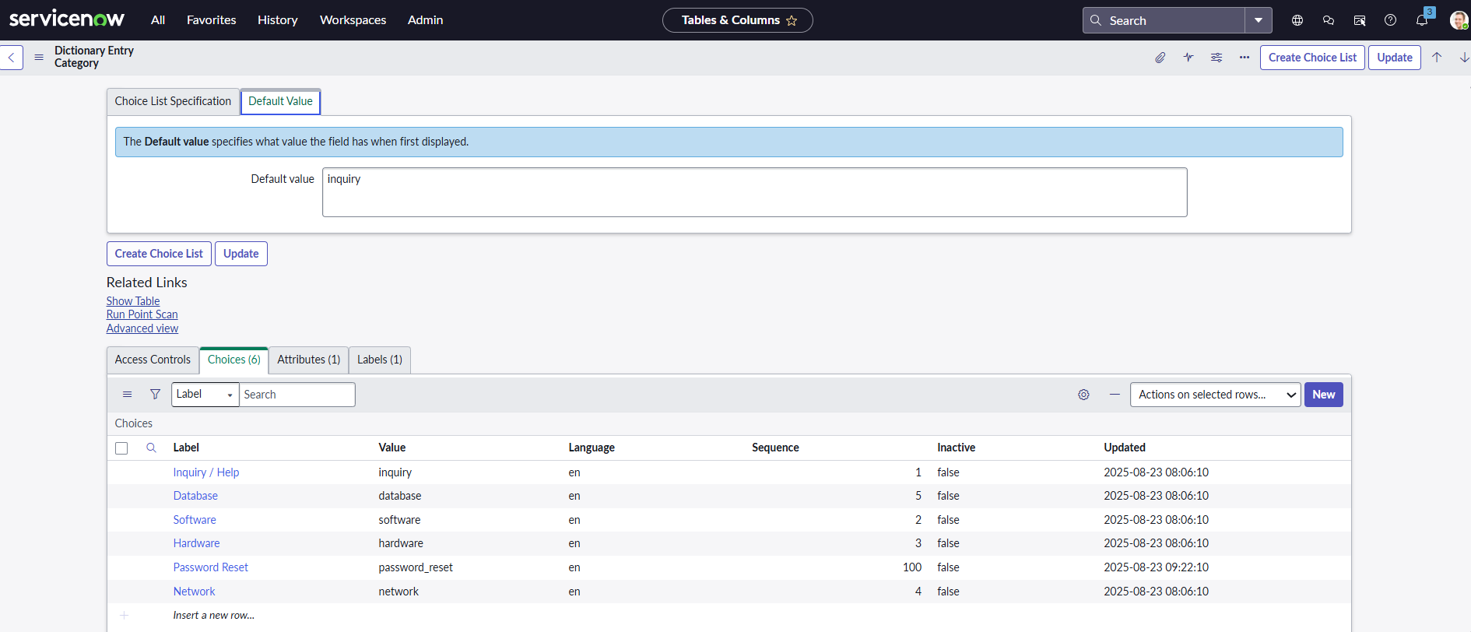

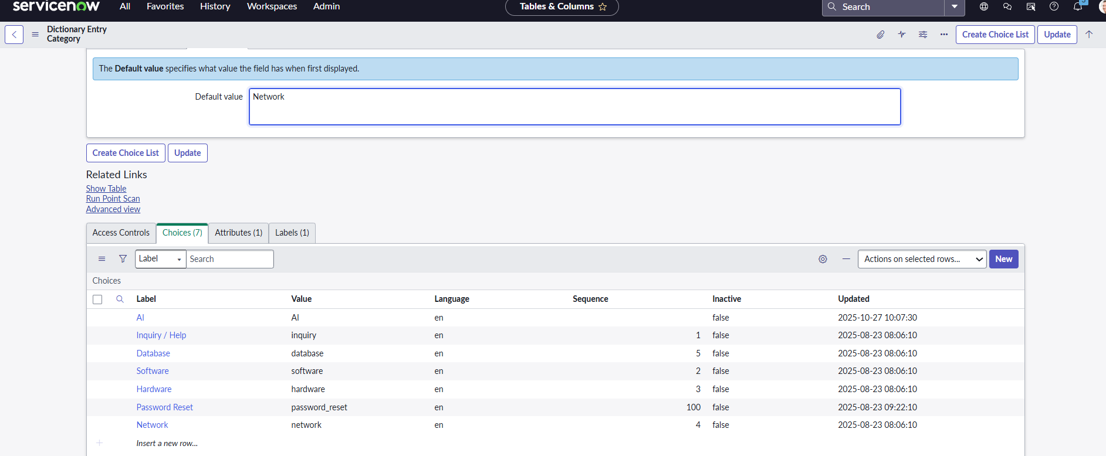
Added new category ….
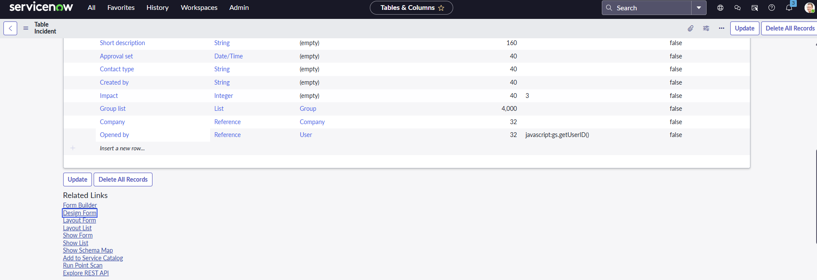
Click on Design Form…
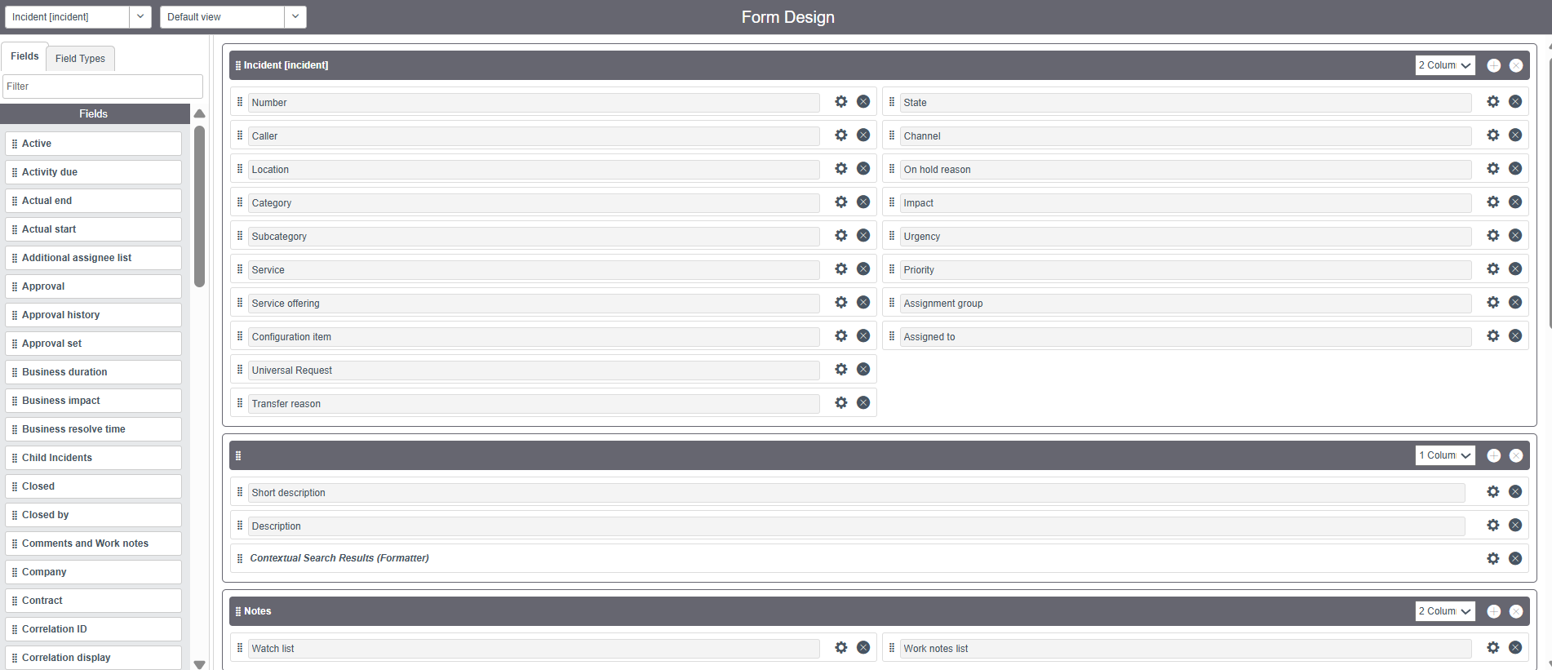
Edit form field …
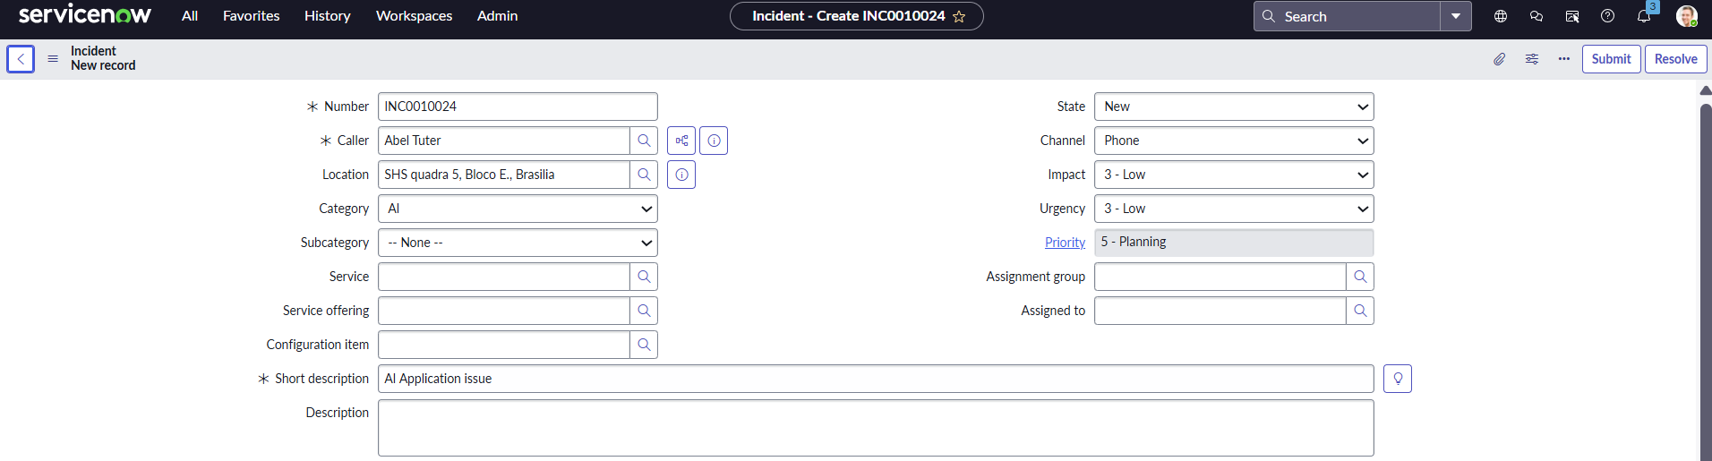

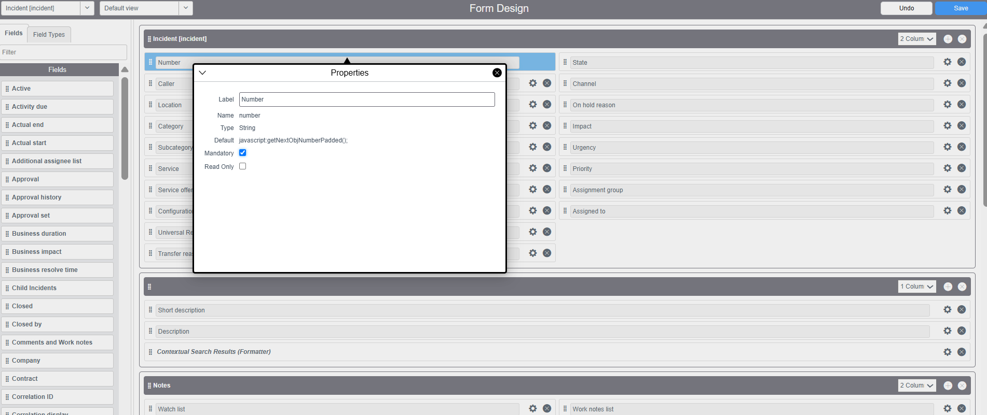
The most common configuration tasks in ServiceNow! Adding a new category to the Incident form is a straightforward process, as the Category field is a standard Choice List field.
You do this directly by managing the choices (options) for that field on the Incident table.
Here is the step-by-step process for how to add a new category:

How to Add a New Category to the Incident Form
Step 1: Navigate to the Choice List
The fastest way to manage the options for a field is to go through the form itself.
- Open any existing Incident record (e.g., type incident.do in the filter navigator and press enter).
- Right-click on the Category field label on the form.
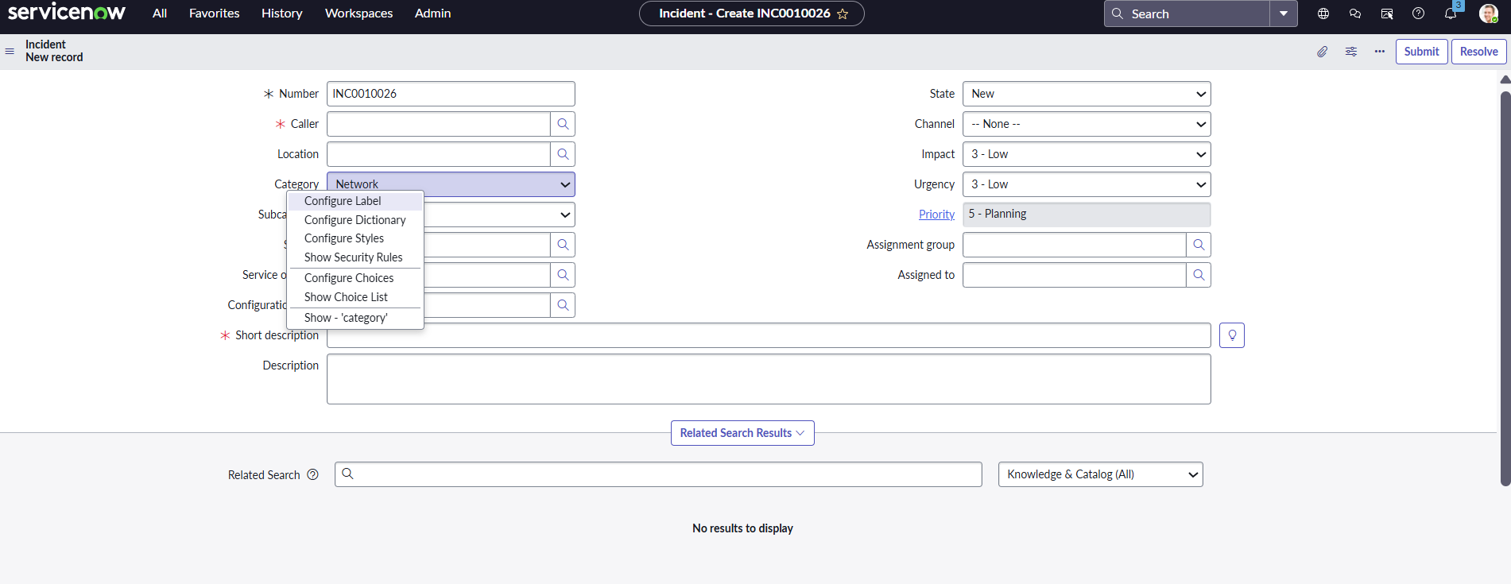
- From the context menu, select Configure Dictionary or Configure Choices. (Choosing Configure Choices is the most direct method).
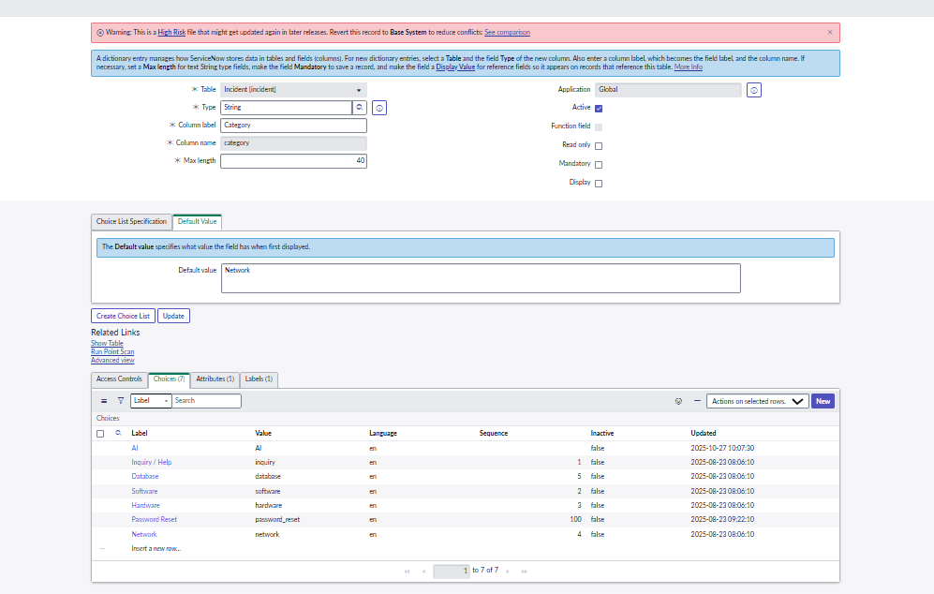
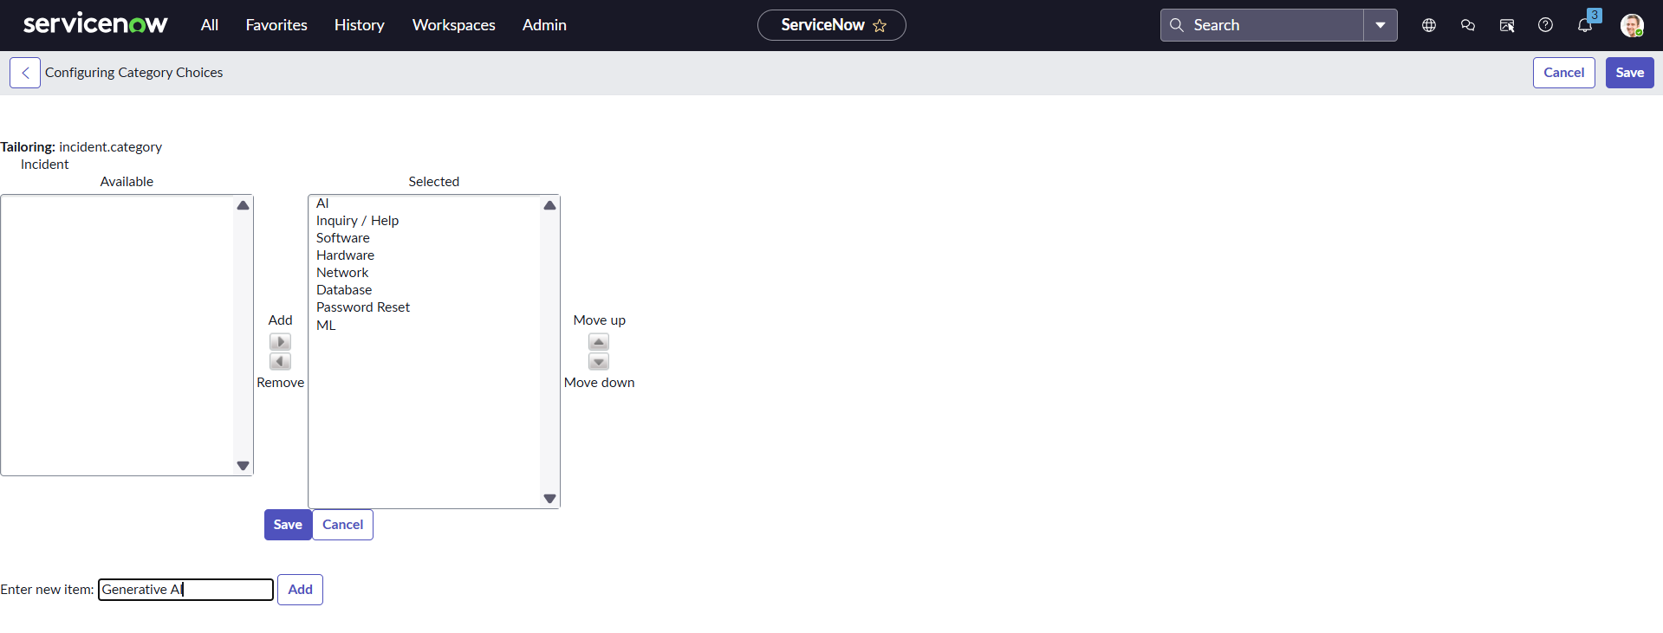
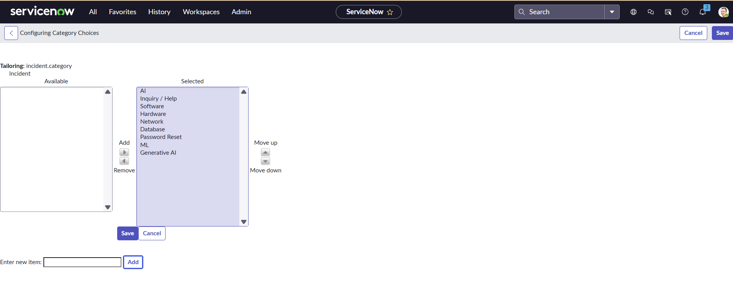
Step 2: Add the New Choice (Category)
You will be taken to a list of existing choices for the category field on the incident table.
- Scroll to the bottom of the list and click the New button.
- Fill in the form for your new category:
  - Table: This should already be set to Incident (or sometimes Task, as the field is inherited, but it's best practice to add choices on the child table).
  - Element: This should be set to category.
  - Value: Enter the backend, technical name for the category (e.g., network_access). This is what the system uses. Use lowercase and underscores, no spaces.
  - Label: Enter the user-friendly name that will appear in the dropdown (e.g., Network Access).
  - Sequence: (Optional) This determines where the option appears in the list. Lower numbers appear first.
- Click Submit or Insert and Stay.
Step 3: Verify the New Category
- Return to an existing Incident record or create a new one.
- Click the dropdown menu for the Category field.
- You should now see your new option, Network Access, listed and ready to be selected by technicians.

Important Considerations:
- Choice vs. Reference Field: The Category field is a simple Choice List. If you wanted a Category structure where one category option determined the next set of options (e.g., Category: Hardware -> Subcategory: Monitor), you would need to also configure the Subcategory field, which is often done via Dependent Choice Fields or Data Lookups.
- Security: You must have the appropriate administrative roles (like admin or itil_admin) to modify the dictionary or choices in ServiceNow.
- Impact on Reporting: Before adding a new category, make sure you communicate it to your reporting teams, as they may need to update dashboards or metrics that filter incidents based on the old categories.

